Legal pitch touches runner in strike zone while attempting to score

As mentioned earlier, rule 5.09(a)(14) of the OBR states that with two out, a runner on third base, and two strikes on the batter, the runner attempts to steal home base on a legal pitch and the ball touches the runner in the batter’s strike zone. The umpire shall call “Strike Three”, the batter is out and the run shall not count; before two are out, the umpire shall call “Strike Three”, the ball is dead and the run counts.
Any advances are recorded with “O/1”, except if an attempt to steal was already under way.
Example 115: With first and third bases occupied and less than two strikes on the batter, the runner on third is touched by a legally pitched ball while passing through the strike zone.
The umpire allows the run, charges a strike to the batter and awards the other runner second base.
The run counts as “stolen” while the advance to second base is recorded with the abbreviation “O/1.
WBSC |  | Traduction dans l’outil de scorage |  | Outil
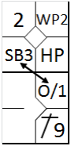 |  | /* Le premier batteur gagne la première base sur un 'Hit by pitch' */  action { batter -> HP }  /* Le coureur avance sur un lancer fou */  action { runner1 -> WP}  /* Le batteur suivant frappe un hit en champ droit, le coureur avance */  action { batter -> 1B9 , runner2 -> +}  /* Un coureur vole la base, le second avance sur une indifférence */  action { runner1 -> O/1 , runner3 -> SB } |  | 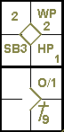

Example 116 starts with the same situation as example 113, but now the second runner was trying to steal the next base: both are credited with a stolen base.
WBSC |  | Traduction dans l’outil de scorage |  | Outil
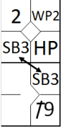 |  | /* Le premier batteur gagne la première base sur un 'Hit by pitch' */  action { batter -> HP }  /* Le coureur avance sur un lancer fou */  action { runner1 -> WP}  /* Le batteur suivant frappe un hit en champ droit, le coureur avance */  action { batter -> 1B9 , runner2 -> +}  /* les deux coureurs volent une base */  action { runner1 -> SB , runner3 -> SB } |  | 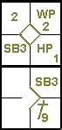

Example 117: With first and third bases occupied, less than two out and two strikes on the batter, the runner on third tries to steal home base but is touched by the ball while
passing through the strike zone.
The umpire calls out the batter on the third strike, validates the run and awards the other runner an addition al base.
The scorer therefore credits the runner who scored with a stolen base, and notes down the advance to second with the notation “O/1”.
WBSC |  | Traduction dans l’outil de scorage |  | Outil
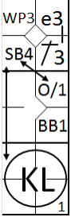 |  | /* Le premier batteur frappe un hit sur la première base et profite d'une erreur pour gagner la deuxième */  action { batter -> 1B3 e3 }  /* le coureur profite d'un lancer fou pour gagner la troisième base */  action { runner2 -> WP }  /* Le batteur suivant gagne la première base sur un 'base on ball' */  action { batter -> BB }  /* Le batteur est strike out, un coureur vole le marbre et l'autre avance sur une indifférence */  action { batter -> KS , runner1 -> O/1 , runner3 -> SB } |  | 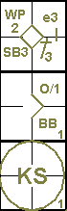

Example 118: With first and third bases occupied, two out and two strikes on the batter, the runner on third is touched by the ball in the strike zone as he is trying to score.
The umpire calls out the batter and (as this is the third putout) no run is scored.
WBSC |  | Traduction dans l’outil de scorage |  | Outil
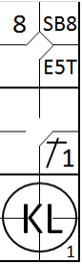 |  | /* le premier batteur arrive sur base sur une erreur de relance du défenseur de la cinquième base */  action { batter -> E5T }  /* Le coureur vole une base */  action { runner1 -> SB }  /* Le batteur suivant frappe un simple sur le lanceur, le coureur avance d'une base */  action { batter -> 1B1 , runner2 -> +}  /* le batteur est strike out */  action { batter -> KL } |  | 